**Experiment no: 11**

**Q1. Border Layout: Implement following Example of Border Layout.**

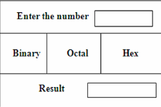

**Answer:**

import javax.swing.*;

import java.awt.*;

import java.awt.event.*;

public class ConverterApp extends JFrame implements ActionListener {

    private JTextField inputField, resultField;

    private JButton binaryBtn, octalBtn, hexBtn;

    public ConverterApp() {

        setTitle("Number Converter");

        setSize(400, 200);

        setDefaultCloseOperation(JFrame.EXIT_ON_CLOSE);

        setLayout(new BorderLayout());

        JPanel topPanel = new JPanel();

        topPanel.add(new JLabel("Enter the number"));

        inputField = new JTextField(15);

        topPanel.add(inputField);

        add(topPanel, BorderLayout.NORTH);

        JPanel centerPanel = new JPanel(new GridLayout(1, 3));

        binaryBtn = new JButton("Binary");

        octalBtn = new JButton("Octal");

        hexBtn = new JButton("Hex");

        centerPanel.add(binaryBtn);

        centerPanel.add(octalBtn);

        centerPanel.add(hexBtn);

        add(centerPanel, BorderLayout.CENTER);

        JPanel bottomPanel = new JPanel();

        bottomPanel.add(new JLabel("Result"));

        resultField = new JTextField(15);

        resultField.setEditable(false);

        bottomPanel.add(resultField);

        add(bottomPanel, BorderLayout.SOUTH);

        binaryBtn.addActionListener(this);

        octalBtn.addActionListener(this);

        hexBtn.addActionListener(this);

        setVisible(true);

    }

    public void actionPerformed(ActionEvent e) {

        String input = inputField.getText().trim();

        try {

            int number = Integer.parseInt(input);

            if (e.getSource() == binaryBtn) {

                resultField.setText(Integer.toBinaryString(number));

            } else if (e.getSource() == octalBtn) {

                resultField.setText(Integer.toOctalString(number));

            } else if (e.getSource() == hexBtn) {

                resultField.setText(Integer.toHexString(number).toUpperCase());

            }

        } catch (NumberFormatException ex) {

            resultField.setText("Invalid number");

        }

    }

    public static void main(String[] args) {

        new ConverterApp();

    }

}

Output:

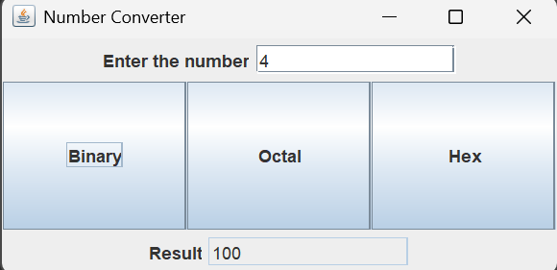

**Q2. FlowLayout: Create a Java program using FlowLayout (aligned left, with horizontal gap 10px and vertical gap 20px) that adds three checkboxes labeled "Java", "Python", and "C++" into the frame.**

**Answer:**

import java.awt.*;

import java.awt.event.*;

public class FlowLayoutExample {

    public static void main(String[] args) {

        Frame frame = new Frame("FlowLayout Example");

        frame.setLayout(new FlowLayout(FlowLayout.LEFT, 10, 20));

        Checkbox javaCheckBox = new Checkbox("Java");

        Checkbox pythonCheckBox = new Checkbox("Python");

        Checkbox cppCheckBox = new Checkbox("C++");

        frame.add(javaCheckBox);

        frame.add(pythonCheckBox);

        frame.add(cppCheckBox);

        frame.setSize(300, 200);

        frame.setVisible(true);

        frame.addWindowListener(new WindowAdapter() {

            public void windowClosing(WindowEvent e) {

                frame.dispose();

            }

        });

    }

}

Output:

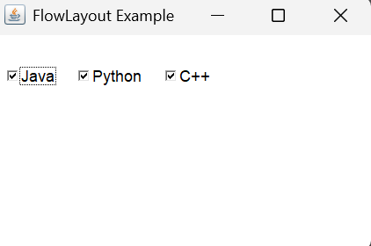

**Q3. GridLayout: Create a program that demonstrates the use of GridLayout. Display a 2x3 grid with the following numbers inside each box. Also, when the user clicks on any box, the number inside that box should swap with the number**

**Answer:**

import java.awt.*;

import java.awt.event.*;

public class SimpleGridLayout {

    public static void main(String[] args) {

        Frame frame = new Frame("GridLayout Example");

        Panel panel = new Panel();

        panel.setLayout(new GridLayout(2, 3));

        for (int i = 1; i <= 6; i++) {

            panel.add(new Button(String.valueOf(i)));

        }

        Button changeBtn = new Button("Change Layout");

        changeBtn.addActionListener(new ActionListener() {

            public void actionPerformed(ActionEvent e) {

                panel.setLayout(new GridLayout(3, 2));

                frame.validate();

            }

        });

        frame.add(panel, BorderLayout.CENTER);

        frame.add(changeBtn, BorderLayout.SOUTH);

frame.setSize(300, 200);

        frame.setVisible(true);

        frame.addWindowListener(new WindowAdapter() {

            public void windowClosing(WindowEvent we) {

                frame.dispose();

            }

        });

    }

}

Output:

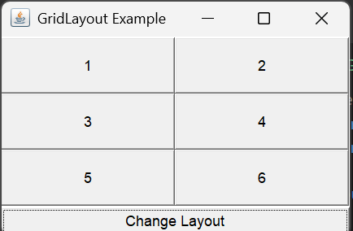

**Q4: Write a GUI program to find the factorial of a given number using applet. (You will need Java 8 to run applet)**

**Answer:**

import java.applet.*;

import java.awt.*;

import java.awt.event.*;

public class FactorialApplet extends Applet implements ActionListener {

    Label label;

    TextField inputField;

    Button computeButton;

    String result = "";

    public void init() {

        label = new Label("Enter a number:");

        inputField = new TextField(10);

        computeButton = new Button("Find Factorial");

        add(label);

        add(inputField);

        add(computeButton);

        computeButton.addActionListener(this);

    }

    public void actionPerformed(ActionEvent e) {

        try {

            int num = Integer.parseInt(inputField.getText());

            long fact = 1;

            for (int i = 1; i <= num; i++) {

                fact *= i;

            }

            result = "Factorial of " + num + " is: " + fact;

        } catch (NumberFormatException ex) {

            result = "Invalid input!";

        }

        repaint();

    }

    public void paint(Graphics g) {

        g.drawString(result, 20, 120);

    }

}

Output: